1.48: a) 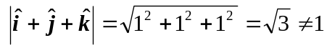 so it is not a unit vector

b) 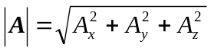

If any component is greater than + 1 or less than –1, 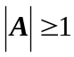, so it cannot be a unit vector. 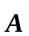can have negative components since the minus sign goes away when the component is squared.

c)
